**Class Activity: Notifications**

1. Stay Notified!

In this activity, we will be creating an application with 2 buttons, one will make a basic notification appear and the other for making a Toast notification appear.

First, create we will create a layout with two buttons, “Basic Notification” and “Toast Notifcation”.

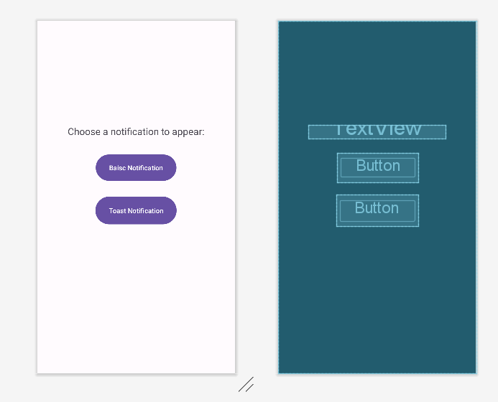

In the main activity, follow the steps to setup a notification channel, build a notification and a toast from the slides. You can fill the contents of the basic notification and toast notification with whatever you want. When the user clicks on the “Basic Notification” the basic notification will appear and when the “Toast Notification” is clicked, the toast notification will appear.

**Things to note**:

If you have a permission error for this line of code:

notificationManager.notify(notificationId, builder.build());

you can ignore the error and run the application.

Ensure that you have the notifications for this application enabled in your mobile settings:

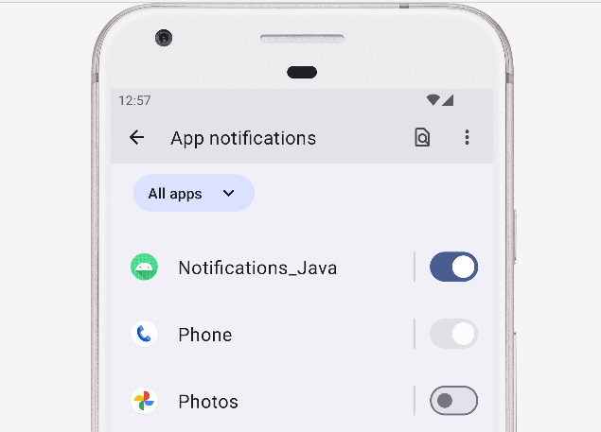

**Expected output:**

